**Potential heirs to the English throne in 1066: Who should become king?**

Lunt’s Heath Primary School Normans Knowledge Organiser Year 5

**Britain before 1066**

**Anglo-Saxons: People who lived in Britain from the 5th century. They included people from Germanic tribes who migrated to the island from Europe.**

**Heir: a person who is legally allowed to take the rank and property of someone who has died.**

**Witan: Kings Council, made up of powerful Bishops and Earls, helped the king run the country**

**Edward the Confessor: 1042-1066**

• Edward became king of England in 1042 after his half-brother died. Before this he had been living in Normandy.

• Edward married but had no children. It was not clear who Edward wanted to be king after him. **For a king to die without an heir was a disaster!**

• He was made a saint and ‘the confessor’ means someone that is saint-like but not a martyr.

**William of Normandy**

Duke of Normandy, France.

William came from a fighting family. He was a brave solider.

Edward’s cousin. Edward had lived in Normandy from 1016-1042. Edward had supposedly promised that William should become King of England

**Harold Godwinson**

Anglo-Saxon. Earl of Wessex, one of the most powerful men in England

Harold’s sister was married to King Edward. Harold was a brave and respected solder with a tough streak.

The Witan, wanted Harold to be the next king.

**Harald Hardrada**

Viking King of Norway

Vikings had ruled Britain before. Most feared warrior in Europe –Hardrada means ‘hard ruler’ and his nickname was ‘the Ruthless’. Harald was supported by Tostig, Harold Godwinson’s brother who wanted revenge.

**Armies at the Battle of Hastings**

**Why did William win the battle of Hastings?**

**Leadership**

William was very brave and led his men very well.

William showed his face during the battle to keep his solders from running away.

**Luck**

The weather changed when William was trying to

Harold had to fight the Vikings first this gave William the advantage.

The Saxons left the shield wall to chase the Normans down the hill.

At a key moment in the battle Harold was killed.

**Preparations**

William had well trained and professional soldiers. Large parts of Harold’s army was untrained and made up of farmers. Many of Harolds men had left the army to collect the harvest in. Harold was not prepared for the battle.

William's army was fresh and well rested. He had lots of supplies. Harold’s was tried and reduced in size following the Battle of Stanford Bridge.

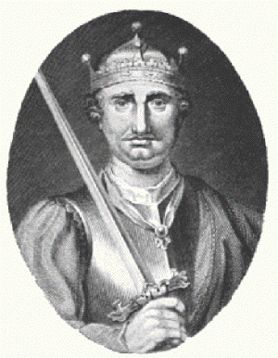

**Castles**

William also kept control by building castles throughout England.

Over time 3 types of castles developed throughout Britain.

**Motte and Bailey – The first castles built to help**

fight against rebellions. They were built

quickly and made out of wood, meaning

that they were not very strong,

and could be easily destroyed.

The Bailey was on flat land, where majority

of the people lived. The Motte was the

higher land of the castle, where the

fort was.

**Stone Keep – This castle was now made**

out of stone and had towers as a form

of defence. The main part of the castle

was the Keep, a large square tower,

used as the main defence.

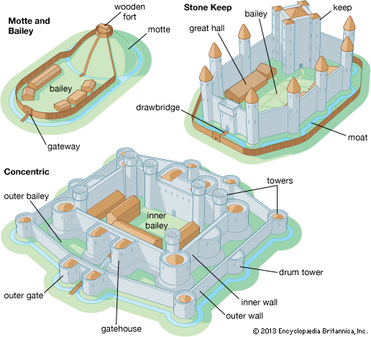

**The Feudal System**

After taking the throne in 1066, William has a few problems:

- He does not trust the English lords, who do not like him.

* He has to force the English to accept him as King.
* Many of the English are rebelling and fighting against William.
* He has to pay the French Knights who helped him to win

the throne.

**Solution: William crushes the rebellions and took the land away** from the English lords and gave it to his supporters instead.

William now has his supporters helping him to control the whole country.

William also sets up the **Feudal System**. This forces the English to give William their taxes and promises of loyalty, in return for protection and land to farm. William is at the top of the system, as he holds all the land and money, which he gives to the Barons. They promise William their money, soldiers and loyalty. They give the land to the Knights in return for loyalty and military service. Finally the knights give the land to the peasants. The peasants farm the land and give food, money and services to the knights.

**The Domesday Book**

In 1086, William sent out surveyors to every part of England, with orders to list:

* how much land was there
* who had owned it in 1066, and who owned it now
* what was the place like, and who lived there
* how much it was worth in 1066 and how much now

William did this to allow him to effectively tax the land and earn money.

William also needed to have an idea of what could be seized from landowners who did not show him loyalty.