**Year 5 Christianity - Jesus**

**Year 5 Key Question** (to be used all year): Where can we find guidance about how to live our lives?

**Focus Question** (for this investigation): What do we mean by a miracle?

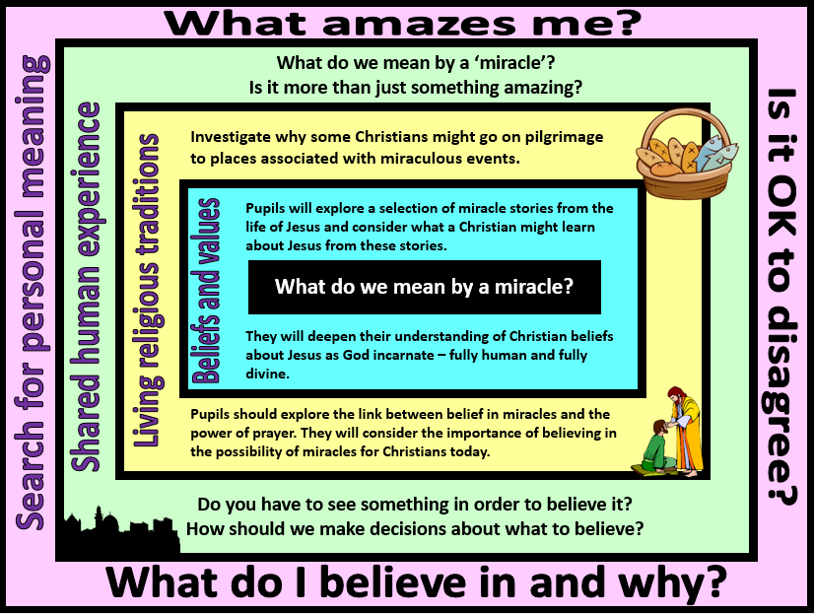

|  |
| --- |
| **Focus Question: What do we mean by a miracle?**  This unit enables pupils to explore what the Christian belief in Jesus as ‘fully human and fully divine’ means. They will build on their prior learning about the incarnation and to consider why some people regard the miracles of Jesus as signs of his divine nature. They might also reflect on what miracles such as healing the sick and feeding people reveal about the humanity of Jesus.  Pupils should have opportunities to discuss why some people believe in miracles and why others do not. In the context of Christianity, they should understand the importance for many Christians, of believing in the possibility of miracles and in belief in the resurrection of Jesus.  Pupils will investigate why some Christians might want to travel to a place associated with a miracle. They should reflect on the impact of bringing beliefs to life by standing in the place where an important event is believed to have happened. They should consider the meaning of the word faith and the experiences that might strengthen the faith of a believer. |

|  |  |  |  |
| --- | --- | --- | --- |
| **Y5 Learning - children will:** | | | |
| * describe Christian beliefs about miracles as ‘signs’ of the divinity of Jesus * retell a selection of miracle stories – and explain what these might reveal to Christians about the nature of Jesus | * describe why some Christians might go on pilgrimage to places associated with miraculous events * explain the impact that belief in miracles and the power of prayer might have on a Christian | * explain the difference between fact, opinion and belief * consider differing interpretations of the word miracle – i.e. an amazing event, a very lucky experience, a strange coincidence, an act of God | * discuss their own beliefs – is there anything that they accept as truth which others may not agree with? * reflect on how they make decisions about what is/is not true |
| **Beliefs and values** | **Living religious traditions** | **Shared human experience** | **Search for personal meaning** |