**Year 5 Hindu dharma**

**Year 5 Key Question** (to be used all year): Where can we find guidance about how to live our lives?

**Focus Question** (for this investigation): What might Hindus learn from stories about Krishna?

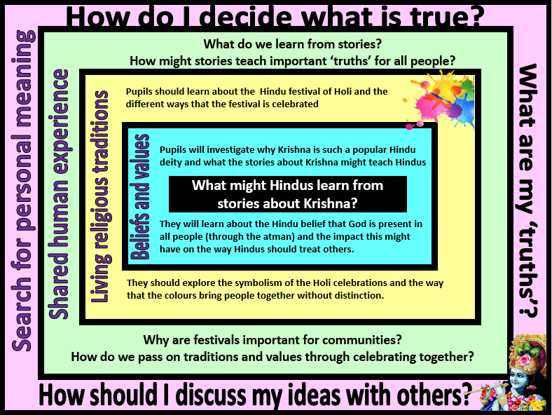

|  |  |  |  |  |
| --- | --- | --- | --- | --- |
| **Focus Question: What might Hindus learn from stories about Krishna?**  This unit enables pupils to examine how Hindu truths are transmitted using stories from revered literature. The focus includes beliefs about Brahman, Vishnu, Avatar (especially Krishna) and Scriptures. Opportunities are provided for pupils to explore some forms of Hindu literature and the beliefs and practices associated with a key story.  Pupils will need to revisit prior learning – in order to understand this unit, they need to know that Hindus believe in one God in many forms (Brahman) and that Vishnu is a popular form of Brahman as he is seen as the protector and preserver. One way that Vishnu fulfils this role is through avatars. They will already be aware of one of Vishnu’s avatars (Rama) through learning about Diwali and the story of Rama and Sita.  Pupils should also be encouraged to consider whether there are links between the ‘truths’ and values revealed in the story and their own beliefs, values and experiences. | | | | |
| **Y5 Learning - children will:** | | | |
| * make links between the story of Prince Prahlad and Hindu beliefs about devotion and loyalty  * explain Hindu beliefs about Krishna and what stories about Krishna might teach Hindus  * explain the Hindu belief that God is present in all people (through the atman) and the impact this might have on a believer | * describe and explain a variety of ways that Hindus might celebrate the festival of Holi  * suggest why there might be differences in the way that Hindu festivals are celebrated in India and how Hindu communities and individuals in the UK might celebrate  * explain how Holi celebrations might express Hindu beliefs about equality | * explain how festivals and celebrations might be helpful ways for communities and societies to pass on values, guidance and traditions  * consider the different ways that myth and stories are and used  * explain how a ‘truth’ might be contained within a story | * consider how they decide what is ‘true’ – and how there might be different types of truth (eg. empirical truth, historical truth, spiritual truth)  * discuss and debate things that they consider to be true that others might disagree with |
| **Beliefs and values** | **Living religious traditions** | **Shared human experience** | **Search for personal meaning** |