What? (Key Knowledge)
Sikhism
Sikhism is one of the world’s major religions. It is the world’s 5rd largest religion, with about 28 million followers. It began over 500 years ago.
Sikhs are the people who follow Sikhism. Sikhs believe in one God who guides and protects them. Sikhs see everybody as being equal in God’s eyes. Sikhism was founded by a man called Guru Nanak. It is based on what he taught people. They believe that he received messages from God telling them how to live.
Leading a good life and making the right choices are important in Sikhism. Granth Sahib is the holy book of Sikhism. Sikhs worship at home and in Sikh temples called Gurdwaras.
Vaisakhi marks the Sikh New Year. At this time, Sikhs remember when Khalsa was created. -Khalsa was the purified Sikh community created by Guru Gobind Singh, in which all were equal.
-This event takes place in April, and also marks the start of the Harvest.

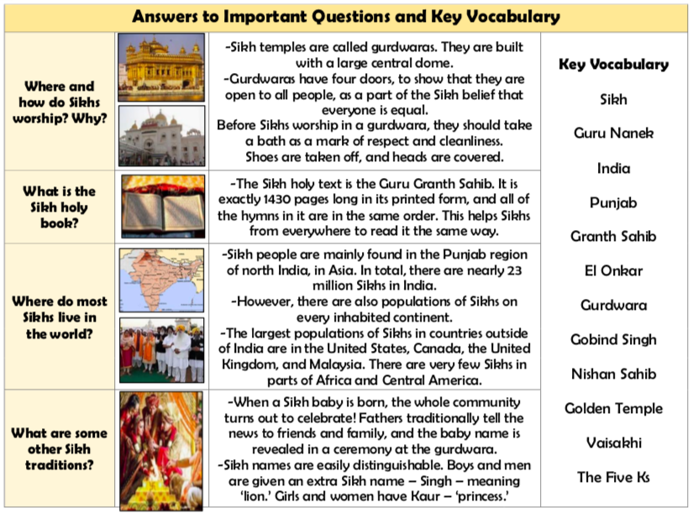

The Five Ks - Sikhs often display their commitment to their religion by adhering to the 5 Ks, which are the ‘Sikh Articles of Faith.’
1. Kesh – Uncut Hair 2. Kangha – Comb
Kara – Steel Bracelet 4. Kirpan – Sword 5. Kaccha – Soldier’s shorts
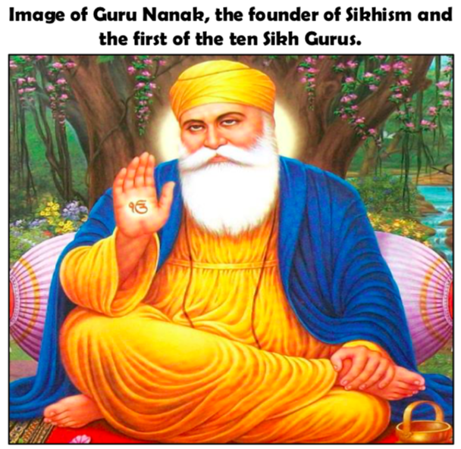
Guru Nanak
-Sikhs believe that Guru Nanak was born in a small village called Punjab in India. He was born into a Hindu family, but grew up around Hindus and Muslims.
-Sikhs believe that Guru Nanak was spoken to by God, who told him to follow a simple faith, in which everybody was equal. In other religions, some people were thought of as better than others.

