Key Questions about Christians
Focus Question: Is sacrifice an important part of religious life?
This unit investigates the person of Jesus through the concept of sacrifice. This links to prior learning about the principle of Zakat in Islam and also what it means to be a follower of Jesus by exploring how Christians might try to follow the example of Jesus through charity and personal sacrifice.

It enables pupils to consider how Jesus’ sacrifices have provided a model for other Christians to mirror by showing agapé (selfless love for others). They will have opportunities to reflect on their own values and on what influences their choices.

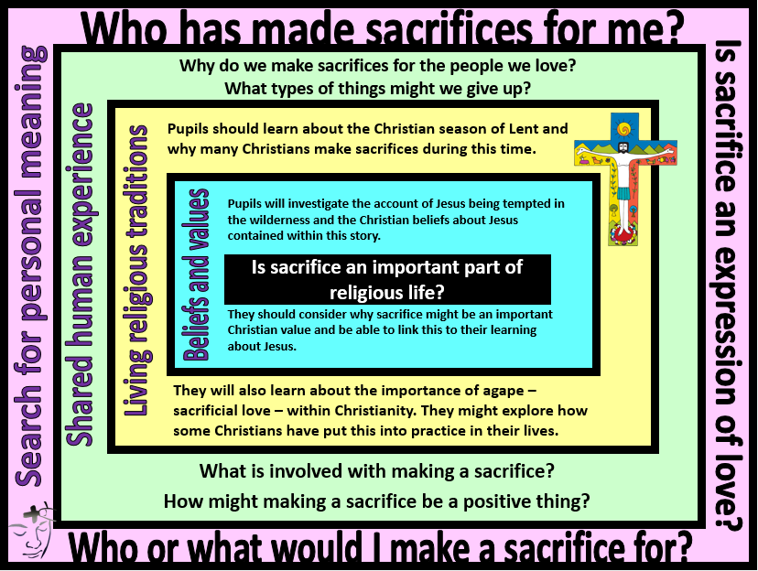

Other Religions
Children will investigate different sacrifices made in different religions e.g. Sikhs not cutting hair or certain religions giving up certain foods or fasting.

