What? (Key Knowledge)
What is the Holy Spirit? | Christians believe it is the third person of the Holy Trinity. It is God’s continued presence on Earth.
What are the symbols of the Holy Spirit? | Water – In baptism it represents the receiving of the Holy Spirit and that it is life-giving quality.  Dove – When Jesus was baptised in the River Jordan, a dove appeared. The dove was a physical sign of God’s presence.  Cloud – combined with light represent God who is hidden from sight but is always there. Also, they provide life-giving water.  Wind – When the Holy Spirit was sent to the disciples, it arrived with a great wind rushing through the room.  Fire – When the disciples received the gift of the Holy Spirit, flames appeared on their head as a sign they were filled with it. This transforming energy would help them teaching others about Jesus and encouraging more followers.  Anointing Oil – Used to anoint people rather like a blessing. It represents Jesus being given the Holy Spirit to heal people and to do good deeds. Oil also reflects the power.
What does worship mean? | This involves praising God (at church) in music and speech, readings from the scripture, prayer, a sermon and other holy ceremonies (called sacraments), such as the Eucharist.
Possible Experiences
- Engage in role play to experience special events.
- Opportunities for discussion to explore the faith.
- Artwork to reflect understanding of Christianity.
What? (Key Vocabulary)
Spelling | Definition/ Sentence
Holy Trinity | The unity of Father, Son and Holy Spirit as three persons in one Godhead.
Pentecost | A festival when Christians celebrate the gift of the Holy Spirit. It is celebrated on the Sunday 50 days after Easter.
Holy Bible | It is the holy scripture of the Christian religion. It is divided into the old testament (focusing on the beginning of the world and humankind) and the new testament (focusing on the life of Jesus).
Sermon | A talk on a religious subject, especially one during a church service and based on a passage from the bible.
Eucharist | A Christian service, ceremony or sacrament celebrating the Last Supper, in which bread and wine are blessed and eaten/drank.
Sacrament | A religious ceremony or ritual regarded as imparting divine grace, such as a baptism and the Eucharist.
Apostle/Disciple | A follower of Jesus.
Symbols of the Holy Spirit
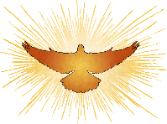

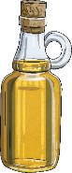



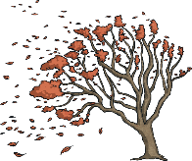

Year 3/4 Spelling Words linked to the unit of work.
appear, believe, experience, guide, heard, important, promise, purpose, special.

