What? (Key Knowledge)
Nutrition
What do animals, including humans need to survive? |  | water, food, air and shelter
What do humans need to do to be healthy? |  | To have a balanced diet of the right amount of different food types and drink.  To exercise regularly.  To be hygienic.
What is nutrition? |  | Nutrition is important for all animals, including humans to enable their growth and maintain their health. This is obtained through the food they consume (eat).
Can an animal, including the human body make their own food? |  | No. Humans and animals can’t make their own food. They can obtain food through growing, hunting or gathering it.
Skeleton and Muscles
What is a skeleton? |  | A skeleton is a structure of bones that supports the body of a person or animal.
What is a muscle? |  | A soft tissue in the body that contracts and relaxes to cause movement of the skeleton.
Possible Experiences
Compare how animals and humans obtain food.
Examine food and nutrient groups.
Explore skeleton types and their main functions.
Investigate how muscles work.

What? (Key Vocabulary)
Spelling | Definition/ Sentence
energy | the strength and vitality for sustained physical or mental activity
healthy | in a good physical and mental health
contract/relax | Muscles which move bones act together in pairs. This means as one muscle contracts, its partner relaxes. Then as the partner muscles contracts the first muscles relaxes again
vertebrate | An animal that does have a backbone
invertebrate | An animal that does not have a backbone
herbivore | An animal that eats mainly plant material e.g. grass, foliage etc.
omnivore | An animal or person that eats both plant material and meat.
carnivore | An animal or person that solely eats meat.
Diagrams and Symbols
The 12 main parts of the skeleton
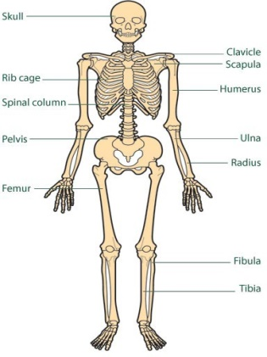
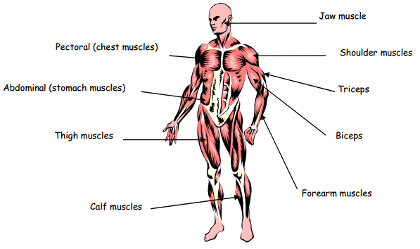

The 10 main muscles in the human body.
Year 3/4 Spelling Words linked to the unit of work.
breathe, breath, exercise, weight, height, strength.

