When? (Time line)
monarch | The King or Queen of a country.
palace | A very large house that is home to the King or Queen.
landmark | An important and well-known building.
coronation | The ceremony at which the King or Queen is crowned.
anniversary | A date celebrated because a special event happened on that date in a previous year.
artefact | An object to help you learn about the past.
oath | A promise.
govern | To be in charge of a place.
archbishop | An important person in the Christian Church.
Queen Elizabeth II
1926 - 2022
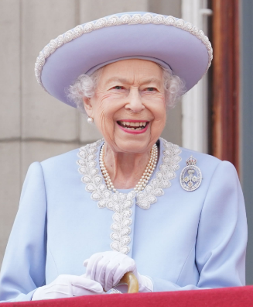
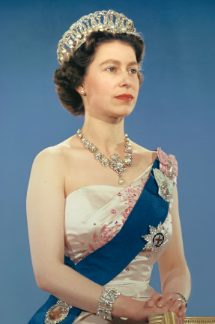
Facts about Queen Elizabeth II
She was born on 21st April 1926 as Elizabeth Alexandra Mary Windsor.
Her father became King in 1936. He was known as King George VI.
Princess Elizabeth (as she was known then) married Philip Mountbatten (Duke of Edinburgh) in 1947.
She had four children: Charles (b. 1948), Anne (b. 1950), Andrew (b. 1960) and Edward (b. 1964).
Elizabeth became Queen in 1952, at the age of 25, when her father died.
In June 1953, Queen Elizabeth II had her coronation.
In June 2022, Queen Elizabeth celebrated her Platinum Jubilee. This meant that she had been on the throne for 70 years.
On Thursday 8th September 2022, Queen Elizabeth died at the age of 96. She was our longest reigning monarch.
Photographs
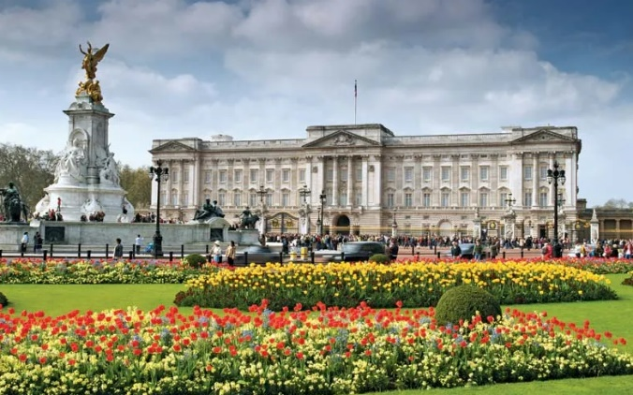
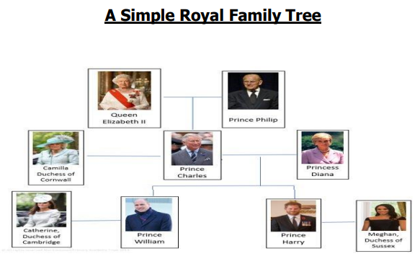
Buckingham Palace was the Queen’s main house in London.
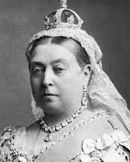

Queen Victoria, at one point, was the longest reigning British monarch.

