**Reception Knowledge Organiser  
Spring 2: Twinkle, Twinkle (Space)**

Next half-term we will be looking at the universe. We will be considering facts like our own sun as a star and how stars make constellations. We will look at what the children already know about space as well as what they would like to know. The children will be encouraged to ask questions in which we will enjoy finding the answers together.

**Our focus books this half-term**

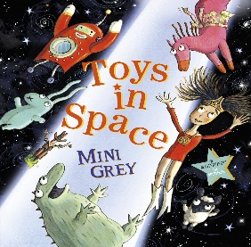[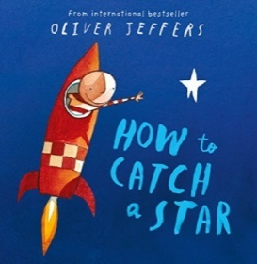](https://www.google.co.uk/url?sa=i&url=https://www.amazon.co.uk/How-Catch-Star-Oliver-Jeffers/dp/0007150342&psig=AOvVaw2PDBpleWFgOEcxpyHlZAU4&ust=1581524400606000&source=images&cd=vfe&ved=0CAIQjRxqFwoTCPjzk9fzyecCFQAAAAAdAAAAABAD)[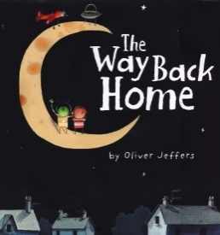](https://www.google.co.uk/url?sa=i&url=https://www.amazon.com/Way-Back-Home-Oliver-Jeffers/dp/0399250743&psig=AOvVaw2neGXIsb2wqjRFz4e_tzCC&ust=1581524321076000&source=images&cd=vfe&ved=0CAIQjRxqFwoTCICu3K_zyecCFQAAAAAdAAAAABAI)[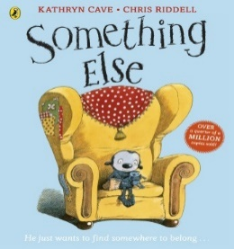](https://www.google.co.uk/url?sa=i&url=https://www.amazon.co.uk/Something-Else-Kathryn-Cave/dp/0141338679&psig=AOvVaw2qvNKch_whVL47jfiS6jVs&ust=1581524362842000&source=images&cd=vfe&ved=0CAIQjRxqFwoTCOC6u8PzyecCFQAAAAAdAAAAABAD)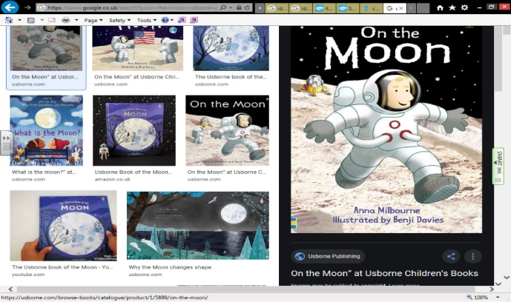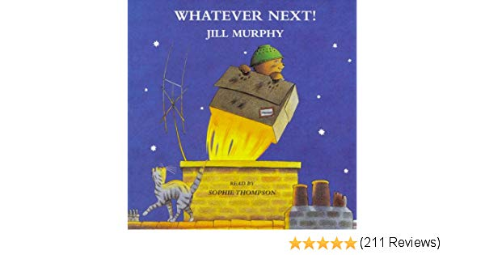

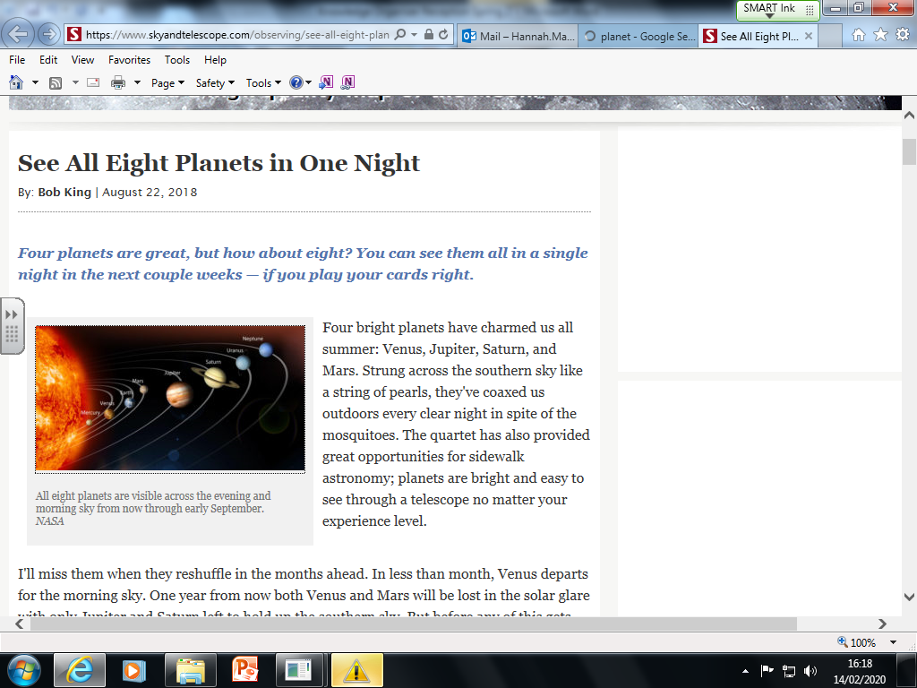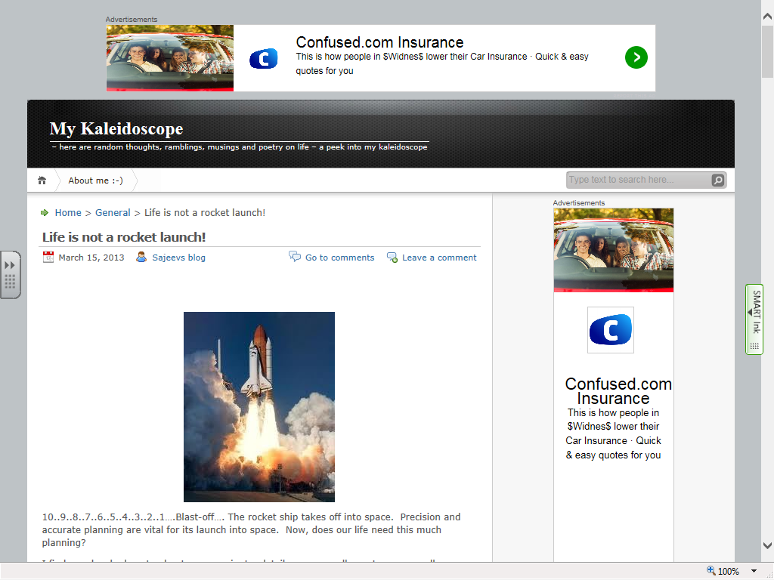[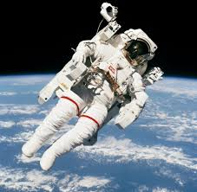](https://www.google.co.uk/url?sa=i&url=https://www.nasa.gov/astronautprofiles/mccandless&psig=AOvVaw27pEPtTkxdsPB77eN8o7-W&ust=1581525687772000&source=images&cd=vfe&ved=0CAIQjRxqFwoTCPDPocP4yecCFQAAAAAdAAAAABAD)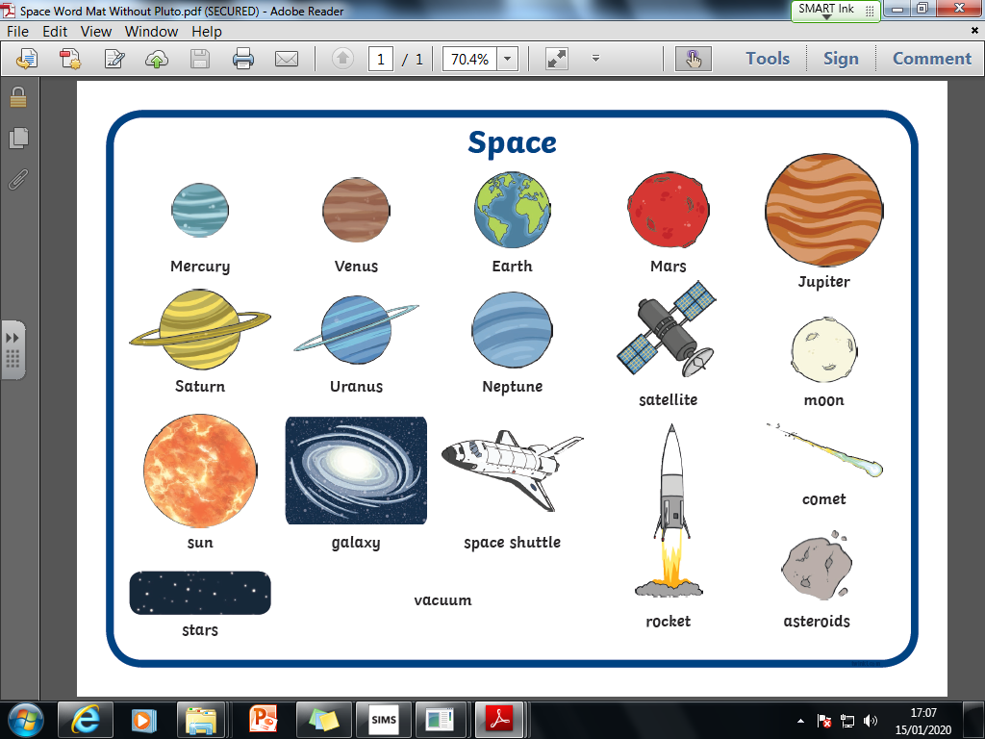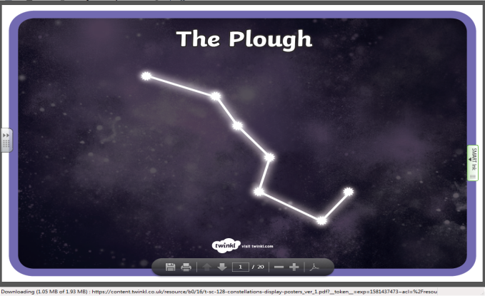

Planet

**Key Questions**

* Can you see a star in the daytime?
* Do stars make patterns and what are their names?
* Why do stars twinkle?
* How many stars are there?
* Is the sun a star?

**Ideas for at home**

* Look out the window at night and in the daytime. Talk about what you can see and compare.
* Look at non-fiction books and use the computer to find out about space.
* Use cardboard to make a rocket or planet.

**Key Vocabulary**