**Reception Knowledge Organiser  
Spring 1: Who can I ask for help? (People Who Help us)**

This half term we will be considering who we can ask for help. This topic enables discussion around future careers and will help give the children aspirations. It also enables them to see the range of helpful people in the community.

**Our focus books this half-term**

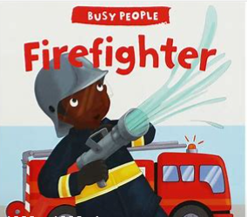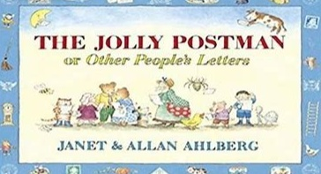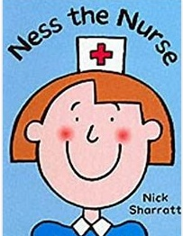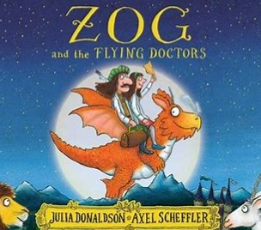

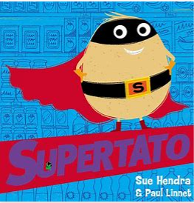

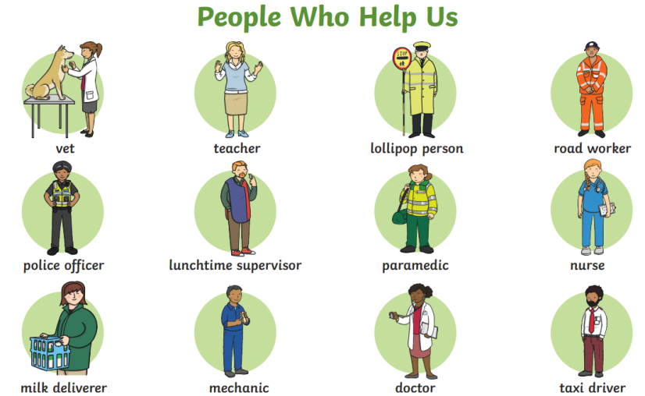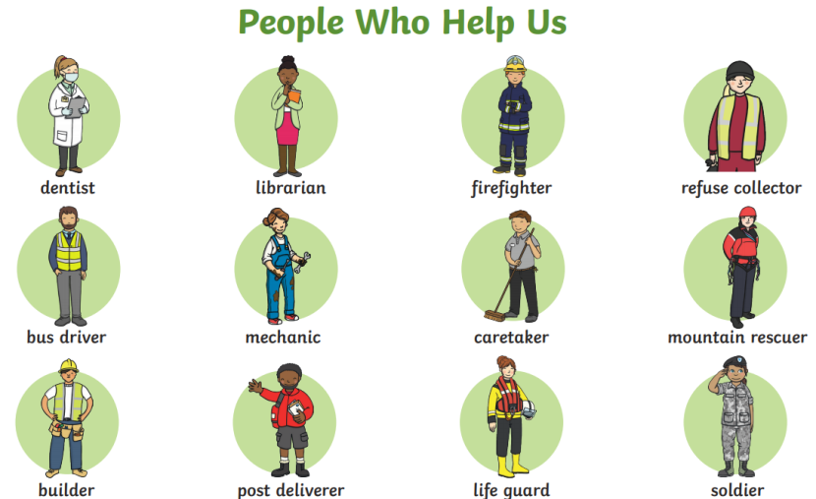

**Key Questions**

* Do all doctors work in hospitals?
* How can Ness the Nurse help me?
* Why do some people wear special clothes to work?
* What does Postman Pat do?
* When would Fireman Sam be very helpful?
* Where do animals go when they need help?
* If you were a superhero, what would your super power be?

**Ideas for at home**

* Learn your address and practise what you would say if you were in an emergency and had to call 999.
* Create your own emergency vehicle. Think about its features – sirens, hosepipes, ladders, bright colours.
* Create a thank you card for someone who has helped you.

**Key Vocabulary**