**Year 5 - Islam**

**Year 5 Key Question** (to be used all year): Where can we find guidance about how to live our lives?

**Focus Question** (for this investigation): Why is the Qur’an important to Muslims?

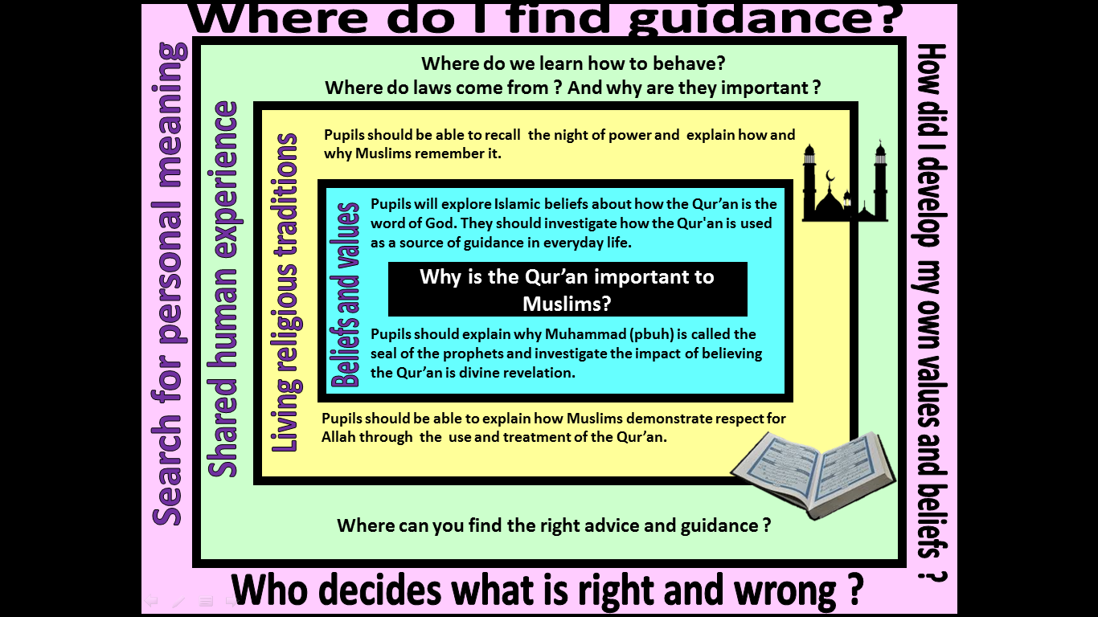

|  |
| --- |
| **Focus Question: Why is the Qur’an important to Muslims?**  This unit enables pupils to explore and examine the origins and role of the Qur’an as a source of wisdom and authority for Muslims. They should gain an understanding of the importance of revelation within Islam and how this impacts on the way that the Qur’an is viewed and treated.  Pupils should make links with prior learning about the night of power (Laylat Ul-Qadr), not only knowing what happened, but also why it is important for Muslims and how it is remembered. They should develop knowledge and understanding of the Prophet Muhammad and how/why he is a role model and source of guidance for Muslims. This is an opportunity to pull together prior learning about the life of the Prophet.  Pupils should have opportunities to discuss what is meant as ‘Ultimate Authority’ and should recognise how this may differ for different members of society – including religious and non-religious individuals and communities. They should be able to link this with their learning about the Qur’an as the word of God and ultimate source of authority for Muslims. |

|  |  |  |  |
| --- | --- | --- | --- |
| **Y5 Learning - children will:** | | | |
| * explore Islamic beliefs about the Qur’an as the word of God * explain how and why the Qur’an is a source of guidance for life for a Muslim * explain the impact of believing that the Qur’an is divine revelation * describe and explain what Muslims believe when they describe Muhammad (pbuh) as the seal of the prophets | * explain how and why Muslims might commemorate the Night of Power * describe and explain a variety of ways that Muslims might show respect for the Qur’an – and how this symbolises their respect for God * explain how the teachings of the Qur’an might influence the actions and choices of a Muslim | * discuss where people might look to for guidance about how to live – consider a range of sources of wisdom and authority * suggest when and why people might want guidance about how to live | * discuss who or what has guided them in their own beliefs, values and commitments * reflect on what ‘ultimate authority’ might mean for them |
| **Beliefs and values** | **Living religious traditions** | **Shared human experience** | **Search for personal meaning** |