
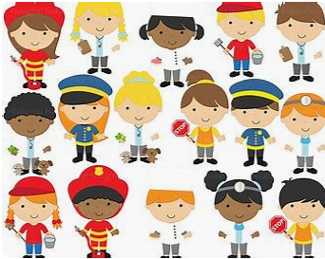
Reception Curriculum Newsletter Spring 1
Classes RL and RH
After a busy first term in Reception, our themes over the coming half term will focus on the seasonal changes we spot in Winter, Lunar New Year and ‘Who can I ask for help?’
We will explore where in the world China is and explore some of the traditions enjoyed during the Chinese festival of New Year. Later on in the half term, we will look at all of the various occupations of people who help us such as doctors, police officers, postal workers, fire fighters and many more! We will also be getting a special visit in a special emergency vehicle too!

In Maths, some of the things we will practise are:
- Counting (exploring zero as an empty set, counting to 10 forwards and backwards, ordinal numbers, matching numeral to quantity with numbers to 10, writing numerals to 10, find number bonds for numbers up to 6)
- Addition (combining two sets up to 10)
- Ordering (compare quantities, count on and back to find 1 more and 1 fewer, order numbers to 10)

In Reception Understanding the World is broken down into three areas:
- People and Communities
- The World
- Technology
An example of some questions that prompt learning in this area are:
- How does Bob the Builder help us?
- What does Postman Pat do?
- Why do we go to school?
- Why is it important to have a hospital?
- When would Fireman Sam be helpful?
Our creative areas are broken down into two areas:
- Creating with Materials
- Being Imaginative and Expressive
An example of what we will be doing in this area is creating Chinese New Year Lanterns.

During indoor PE we will be focusing on Gymnastics with the unit Rocking and Rolling. We will be exploring how to use different parts of our bodies to rock on and using different apparatus safely.
In outdoor PE our unit is Fine Motor Skills. We will be working on our hand strength and showing increasing control.

Literacy
We will continue with our daily phonics sessions following on from our assessments at the end of last term. Your child will be bringing reading materials home based on their current phonic knowledge so we would really appreciate you also hearing them read and leaving a little comment in their reading diaries.
We will also continue with Drawing Club which proved very popular last half term. In Drawing Club we share a different story, traditional tale or short animation each week. The children learn ambitious vocabulary linked to the story before completing a different drawing challenge each day which helps to develop their fine motor skills for writing. The children are doing so well with adding ‘mystery marks’ to demonstrate their writing and mathematics skills which help to give their drawings special powers!

