**Year 5 Christianity - God**

**Year 5 Key Question** (to be used all year): Where can we find guidance about how to live our lives?

**Focus Question** (for this investigation): Why is it sometimes difficult to do the right thing?

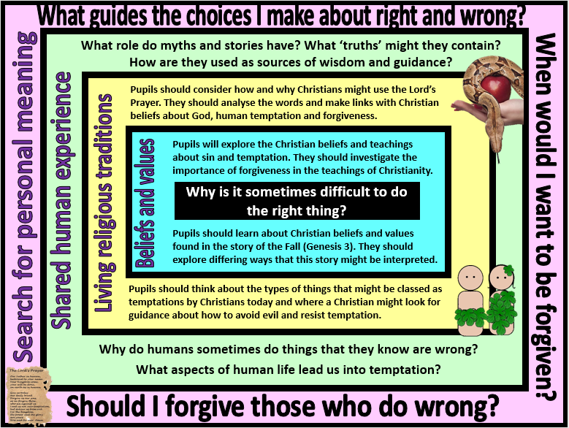

|  |
| --- |
| **Focus Question: Why is it sometimes difficult to do the right thing?**  This unit enables pupils to explore Christian beliefs and teachings about sin and temptation and introduce core Christian concepts such as The Fall, Original Sin, Free Will, forgiveness and reconciliation. Pupils should be encouraged to make links with prior learning about the creation story in Genesis 1 (particularly the point that God made the world ‘and saw that it was good’) and with their knowledge of baptism. They should have the opportunity to analyse and ask questions about the story found in Genesis 3, not simply retell it. Pupils should deepen their understanding of how and why Christians use the Bible by exploring different Christian interpretations of the text – literal and metaphorical – and how this might impact on a believer’s attitude towards sin and temptation in the world today.  Pupils should investigate the importance of forgiveness within the Christian faith and the way this might be put into action by both individuals and communities. They should be able to make links with teachings found in the Lord’s Prayer and other aspects of Christian worship such as prayers of penance, confession and reconciliation.  Pupils should reflect on things that might be seen as ‘temptations’ in modern life. They should be able to consider the role of greed and selfishness in leading people astray from doing the right thing – and ask questions about why we/they do things that we/they know are wrong. They should also be able to talk about their own views about the role of forgiveness: Why might it be important? Should we always forgive? Is it important to say sorry if you want to be forgiven? Why might it sometimes be difficult to forgive? |

|  |  |  |  |
| --- | --- | --- | --- |
| **Y5 Learning - children will:** | | | |
| * describe Christian beliefs about sin and forgiveness  * describe and explain the teaching from Genesis 3 – of how Adam and Eve disobeyed God  * suggest different ways that this story might be understood by Christians | * describe and explain how and why Christians might use the Lord’s Prayer  * analyse and interpret the Lord’s Prayer – and what guidance it provides for Christians  * suggest things that might lead Christians into temptation in the modern world – and how and why they might try to resist these temptations | *consider the different ways that myth and stories are and used  * explain how a ‘truth’ might be contained within a story | * consider how they decide what is ‘true’ – and how there might be different types of truth  * discuss and debate things that they consider to be true that others might disagree with |
| **Beliefs and values** | **Living religious traditions** | **Shared human experience** | **Search for personal meaning** |