What? (Key Knowledge)
Prior Learning
- Experience of using measuring, marking out, cutting, joining, shaping and finishing techniques with construction materials.
- Basic understanding of what structures are and how they can be made stronger, stiffer and more stable.
Designing
- Carry out research into user needs and existing products, using surveys, interviews, questionnaires and web-based resources.
- Develop a simple design specification to guide the development of their ideas and products, taking account of constraints including time, resources and cost.
- Generate, develop and model innovative ideas, through discussion, prototypes and annotated sketches.
Making
- Formulate a clear plan, including a step-by-step list of what needs to be done and lists of resources to be used. - Competently select from and use appropriate tools to accurately measure, mark out, cut, shape and join construction materials to make frameworks.
- Use finishing and decorative techniques suitable for the product they are designing and making.
Evaluating
• Investigate and evaluate a range of existing frame structures.
- Critically evaluate their products against their design specification, intended user and purpose, identifying strengths and areas for development, and carrying out appropriate tests.
- Research key events and individuals relevant to frame structures.
Technical knowledge and understanding
- Understand how to strengthen, stiffen and reinforce 3-D frameworks.
- Know and use technical vocabulary relevant to the project.

Possible Experiences
Design, make and evaluate a Mangonel Catapult.
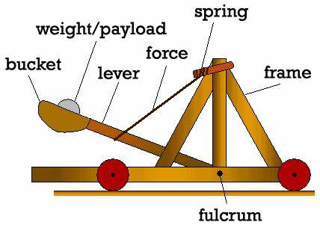
Focus on :
Measuring
strength and stability

What is the purpose of a Roman Catapult?

What? (Key Vocabulary)
Spelling | Definition / Sentence
Ballista | Type of catapult that works a little like a crossbow
Trebuchet | Catapult that uses a counterbalanced weight to fling the object forward
Mangonel | Catapult that uses a bucket and long wooded arm to fling the object forward
Onager | Similar to a Mangonel, but uses a sling to throw items
Prototype | a first or preliminary version of a device or vehicle from which other forms are developed.
Triangulation | the use of triangular shapes to strengthen a structure. •
Diagrams
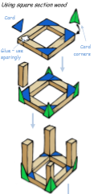
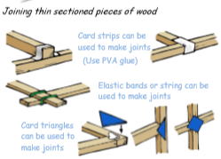

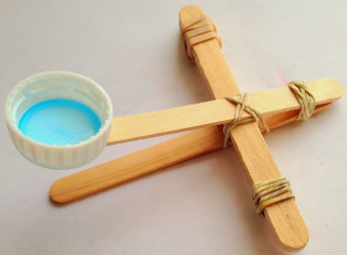

<- Prototype of catapult

