What? (Key Knowledge)
Hinduism
Hinduism is one of the world’s major religions. It is the world’s 3rd largest religion, with about 1.1 billion followers. It is around 5,000 years old.
Hindus are the people who follow Hinduism. It is a very complex religion that is followed by different people in different ways.
Many gods are worshipped in Hinduism. All of these different Gods are believed to be a part of the supreme God named ‘Brahman.’
Hindus believe in karma and reincarnation – that when you die you are reborn as something else.
Hinduism does not have one holy book, but several sacred texts. Mandirs are Hindu worship buildings.

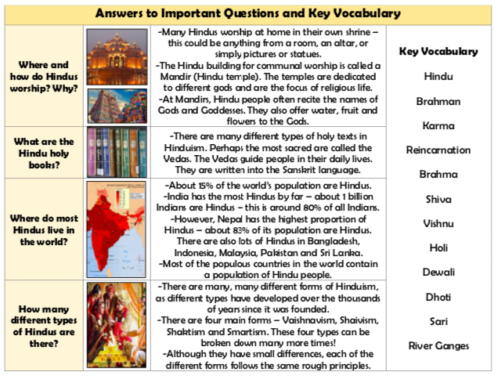

Brahman and the Gods
-Hindus believe in one supreme God called Brahman. He can be found in everyone and everything, including the other Gods.
-Some of the important other Gods include ‘Brahma’ (the creator), ‘Shiva’, (the destroyer) and ‘Vishnu’ (the protector). These three together form the ‘Trimurti’ (trinity).
-Other gods include Ganesh (remover of obstacles), Hanuman (the monkey God), Lakshmi (the Goddess of wealth and good fortune, and Vishnu (the God who preserves life and stands up to evil).

