What? (Key Knowledge)
What is a force? | Forces are pushes and pulls in a particular direction.
What is friction? | This is a force that acts between two surfaces or objects, that are moving or trying to move across each other. Friction always slows a moving object down. For example, when you try to push a book along the floor, friction makes it difficult. The amount of friction depends on the materials from which the two surfaces are made.
What is a magnet? | This is an object which produces a magnetic force that pulls certain objects towards it.
Are all materials magnetic? | The objects that are attracted to a magnet are magnetic, such as metals containing iron, nickel or cobalt. For example, paperclips. Objects that contain wood, plastic or fabric would be non-magnetic.
What is a magnetic field? | This is the area surrounding a magnet where the force is acting on another magnet or magnetic material. It can be observed using a compass placed at different points around a bar magnet.
Possible Experiences
Work scientifically to compare how different things move on different surfaces.
Sort and classify magnetic and non-magnetic materials.
Design, make and evaluate a magnetic game.
Explore how magnetic forces can act at a distance.
What? (Key Vocabulary)
Spelling | Definition/ Sentence
Motion | Moving from one place to another.
Surface | The top layer of something.
Accelerate | Speeding up.
Decelerate | Slowing down.
Balanced Force | When two forces are equal and there is no motion.
Attract | The force of one object pulling another object towards it.
Repel | The force of one object pushing another object away from it.
Poles | North and South poles are found at the different ends of a magnet.
Compass | A tool for finding direction. It contains a magnetic needle, which can spin freely. The needle always points North and will react to nearby magnetic fields. A compass works because Earth is a huge magnet.
Diagrams and Symbols
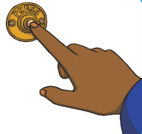
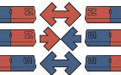
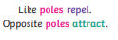
Examples of a push force
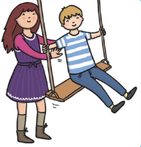
Examples of a pull force
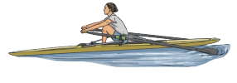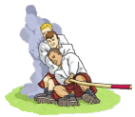
Year 3/4 Spelling Words linked to the unit of work.
Different, difficult, experiment, extreme, forward, group, increase, material, notice, opposite, particular, position, pressure, strength, weight.

