What? (Key Knowledge)
Where is the Mediterranean? | Located in the south-east of Europe also known as the Mediterranean Basin
Which countries surround the Mediterranean sea? | France, Monaco, Italy, Malta, Slovenia, Croatia, Bosnia and Herzegovina, Montenegro, Albania, Greece, Turkey, Cyprus, Syria, Lebanon, Israel, Egypt, Libya, Tunisia, Algeria and Morocco. There are 21 in total
What is the landscape like in the Mediterranean? | The landscape changes considerably from one area to another and varies from high mountains to rocky shores, semi-arid steppes and sandy beaches.
What is a climate zone? | A climate zone is an area that has its own climate.
How many languages are spoken in the Mediterranean? | There are 13 languages spoken within the Mediterranean region  Albanian, Arabic, Croatian, English, French, Greek, Hebrew, Italian, Maltese, Serbian, Slovenian, Spanish and Turkish.
Possible Experiences
Cook a Mediterranean recipe.
Create a piece of artwork in the style of a Mediterranean artist.
Design and build a landmark from the Mediterranean.
What? (Key Vocabulary)
Spelling | Definition/ Sentence
Polar | Below freezing and can reach -60°C in winter. They are usually covered by snow and ice throughout the year
Temperate | Vary greatly at different times of year, with four distinct seasons.
Arid | Lack natural water sources, with little rainfall. They are very dry and hot.
Tropical | High temperature rainfall and humidity all year. Some areas may have a wet and dry season.
Mediterranean | Long, warm, dry summers and wet winters.
Mountainous | Mountains become colder the higher the altitude gets. They also tend to have much wetter climates than the surrounding land.
Tourist | a person who is travelling or visiting a place for pleasure.
Destination | the place to which someone or something is going or being sent.
Landscape | all the visible features of an area of land, often considered in terms of their aesthetic appeal.
Map of Mediterranean Region
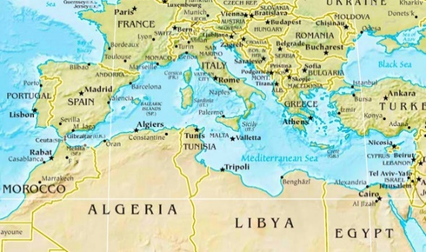
Year 3/4 Spelling Words linked to the unit of work.
believe, busy, different, earth, fruit,, group, island, notice, position,

