What? (Key Knowledge)
What is an igneous rock? | A rock formed from magma or lava.
What is a sedimentary rock? | A rock formed by layers of sediment being pressed down hard and sticking together.
What is metamorphic rock? | A rock that was initially igneous or sedimentary but changed due to extreme heat or pressure.
What is fossilisation? | The process by which fossils are made. (1) An animal dies and is covered by sediment, which eventually becomes rock. (2) More layers of rock cover it and only bones, shells and teeth remain. (3) Over thousands of years, sediment may enter the mould to make a cast fossil. (4) Changes in the sea level take place over a long period. (5) An erosion and weathering occur and eventually the fossil becomes exposed.
What is soil made of? | Soil is the uppermost layer of the Earth. It is a mixture of different things, such as minerals, air, water, and organic matter. The minerals in soil come from finely broken-down rock.
Possible Experiences
Work scientifically to compare and group different rocks based on appearance and physical properties.
Explore and describe how fossils are formed.
Create a compost bin to investigate and identify what soils are made from.
What? (Key Vocabulary)
Spelling | Definition/ Sentence
Durable | Can resist wear, decay, pressure, and damage.
Non-durable | Not resistant to wear, decay, pressure, and damage.
Magma | Molten rock that stays underground.
Lava | Molten rock that comes out of the ground.
Sediment | Natural solid material that is moved and dropped in a new place by water or wind e.g. sand.
Permeable | Allows liquid to pass through it.
Impermeable | Does not allow liquids to pass through it.
Erosion | When water, wind, or ice wears away land.
Weathering | A natural process that slowly breaks apart or changes rock; caused by heat, water, wind, and other natural forces.
Diagrams and Symbols
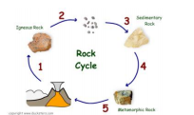
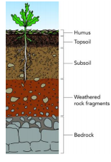
Year 3/4 Spelling Words linked to the unit of work.
Earth, experiment, extreme, increase, natural, pressure, separate, disappear, different.

