Year 5 Judaism
Year 5 Key Question (to be used all year): Where can we find guidance about how to live our lives?
Focus Question (for this investigation): Do people need laws to guide them?

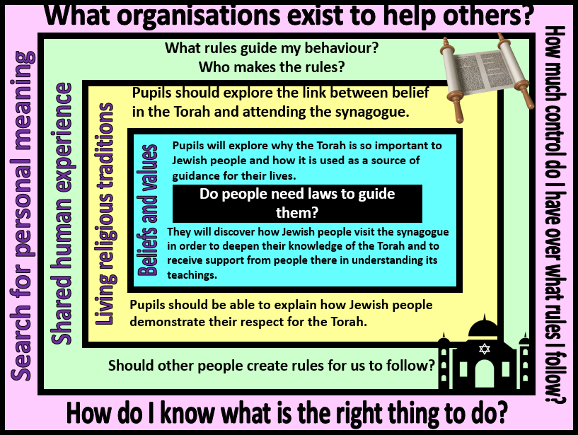
Focus Question: Why is it sometimes difficult to do the right thing?
This unit enables pupils to explore the importance of the Torah to Jewish people as a guide to life and faith. This unit has links with the Year 2 unit ‘What aspects of life really matter?’ and pupils will have opportunities for revisiting prior learning on how the Torah was given to Moses. Pupils will learn that Jewish people attend the synagogue in order to find out more about how to live their lives and to seek guidance from religious leaders. They will explore how the Torah is respected and honoured through Jewish worship and the way that it is used and handled at the synagogue. Pupils will then have time to reflect upon how they personally make decisions and who or what can have influence over this.

Y5 Learning - pupils will:
- Make links between beliefs and sacred texts (in this case, the Torah), including how and why religious sources are used to teach and guide believers  - Explain the impact of Jewish beliefs and values – including reasons for diversity | - Explain differing forms of expression within the context of Jewish worship.  - Describe diversity of religious practices and lifestyle within t  - Interpret the deeper meaning of symbolism – contained in stories, images and actions | - Explain (with appropriate examples) where people might seek wisdom and guidance  - Consider the role of rules and guidance in uniting communities | - Discuss and debate the sources of guidance available to them  - Consider the value of differing sources of guidance
Beliefs and values | Living religious traditions | Shared human experience | Search for personal meaning

