Year 5 Christianity - Church
Year 5 Key Question (to be used all year): Where can we find guidance about how to live our lives?
Focus Question (for this investigation): How do people decide what to believe?

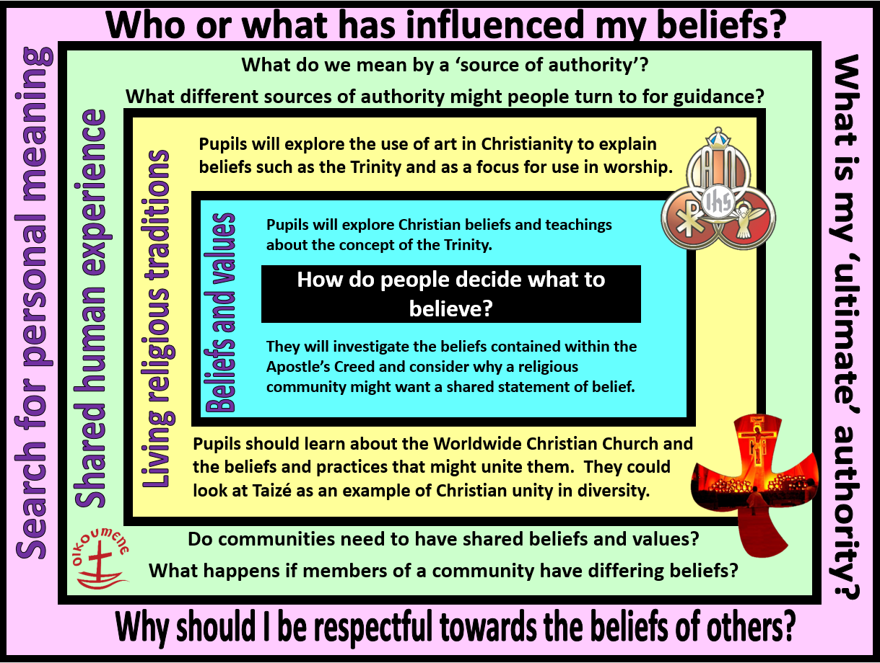
Focus Question: How do people decide what to believe?
This unit enables pupils to explore Christian beliefs and teachings contained in the Apostle’s Creed and how shared beliefs unite the world-wide Church. Pupils should know what is meant by the idea of one God in Trinity and be able to explain the role of each person of the Trinity. They should be able to explain these concepts using subject specific vocabulary and make connections between beliefs, teachings and practices.
Pupils will begin to explore diversity within Christianity by looking at differences in worship. They should consider different ideas about diversity within a community – and the importance of being respectful of difference. Pupils should know that there is one worldwide Christian community - the Church – but that there are many types of Christians and churches that belong to this.
Pupils will have opportunities to explore the question of how people can live together well in modern Britain – and the value of being united in diversity.

Y5 Learning - children will:
- describe what Christians mean when they talk about one God in Trinity  - identify the beliefs contained within the Apostle’s Creed  - explain why the Christian community (The Church) might want/need an agreed statement of belief | - describe and explain the meaning of a range of symbols that might be used for the Trinity  - explain how symbols might unite the worldwide Christian Church  - describe the role of places like Taizé where Christians from different backgrounds might come together to worship | - consider what we mean by sources of authority. Give examples of sources of authority that might guide individuals and communities – and the value of these as guidance for life  - discuss different responses to sources of authority | - raise meaningful questions about things that puzzle them  - differentiate between questions that can be answered factually and those that have a range of answers, including personal beliefs and values
Beliefs and values | Living religious traditions | Shared human experience | Search for personal meaning

