Claude Monet
Claude Monet was born on November 15, 1840 in Paris, but his family moved to the port city of Le Havre, France while he was still young. He loved to draw as a child. He began drawing caricatures of people that were quite good. Even as a kid he was able to make some extra money drawing pictures of people. Around the age of eleven, Claude entered a school for the arts. His mother supported his becoming an artist, but his father wanted him to take over the family grocery business. Claude met some other artists around this time and began to use oil paints to paint the outdoors. A few years after his mother died in 1857, Claude moved to Paris to study art at the Academie Suisse. He was there for about a year when he was drafted into the army. He became sick with typhoid fever in the army and returned home a few years later. Monet continued to paint outdoor scenes. His paintings were becoming accepted by the art critics in Paris. He then decided to take on large project he called Women in the Garden. This was a huge painting, over eight feet tall, that he painted outside in the natural light. It was a normal everyday scene. He spent a lot of time on it, but the critics did not like it. He became depressed and was also out of money. War broke out in France in 1870 and Claude moved with is new wife, Camille, to London. There he met art dealer Paul Durand-Ruel who would become one of his strongest supporters. At this time Monet began to study the relation of the city of London to the River Thames. Monet became friends with several of the leading artists of the time including Pierre Renoir, Edouard Manet, and Camille Pissarro. Together they formed the Society of Anonymous Painters, Sculptors, and Printers. They wanted to experiment with art and not do the same classical art that satisfied the art critics of Paris.
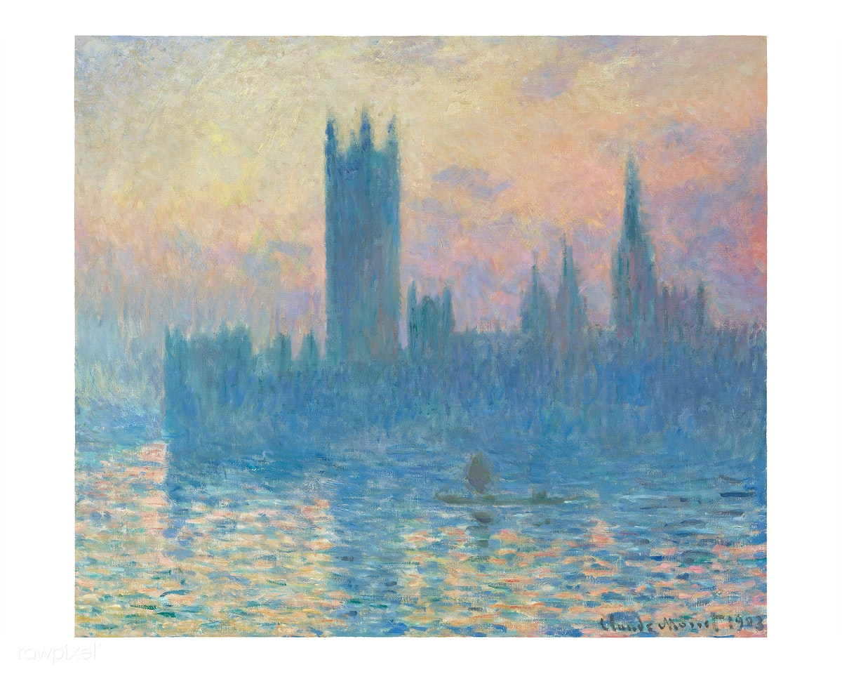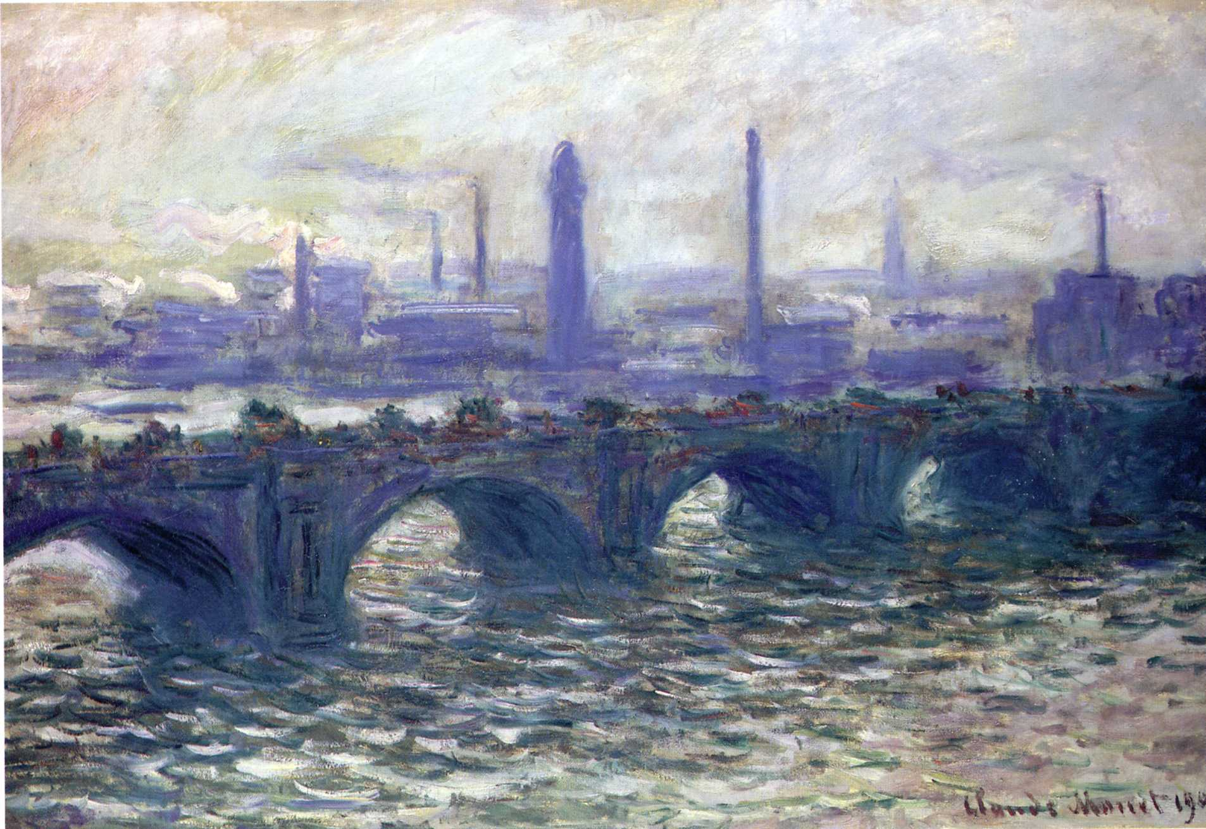
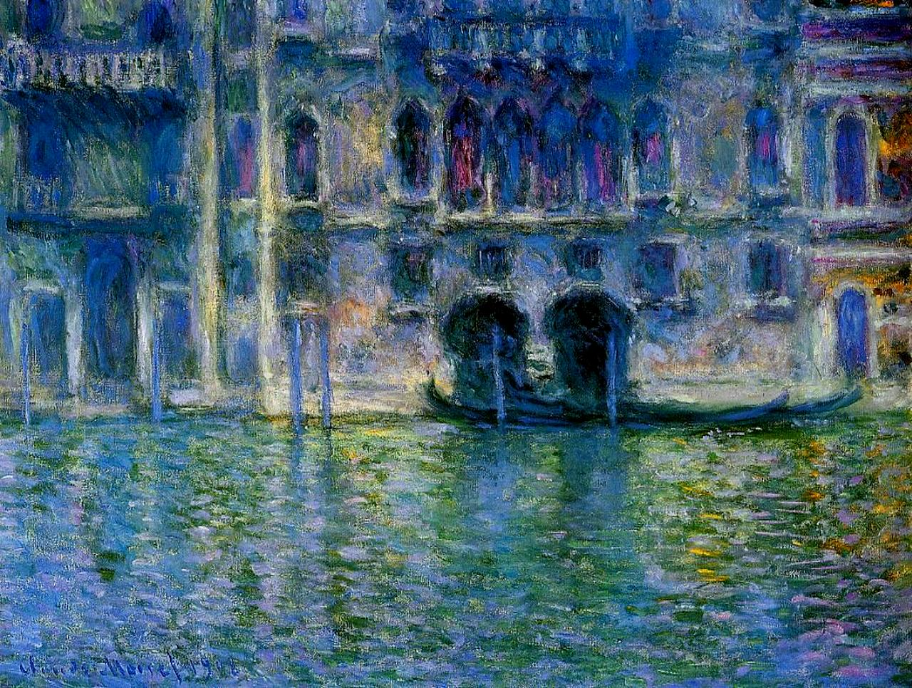

Key Vocabulary and Definitions
Artistic Movement - A group of artists who have agreed to work together to a set of principles or who are perceived to be working collectively by curators, art historians and commentators. For example, Abstract Expressionism, Mannerism and Cubism
Drawing - he art of representing object and forms on a surface chiefly with the use of line and with pencils, crayons, pens and a variety of mark making instruments. Drawing can be further defined to include figure or life drawing, perspective drawing, orthographical drawing and isometric drawing
Perspective - The art of drawing solid objects on a two-dimensional surface so as to give the right impression of their height, width and depth. A picture drawn in such a way, appearing to enlarge or extend the actual space, or to give the effect of distance

