What? (Key Knowledge)
What was the Stone Age? | The Stone Age is the name given to the earliest period of human culture when stone tools were first used.
What was the Bronze Age? | The Bronze Age is the time period when bronze replaced stone as the preferred materials for making tools and weapons.
What was the Iron Age? | The Iron Age is the time period when iron became the preferred choice of metal for making tools.
What is BC? | Before Christ - A way of dating years before the birth of Jesus. The bigger the number BC, the longer ago in history it was.
What is AD? | Anno Domini - “in the year of our Lord”. AD is used to show dates after the birth of Jesus. This year is AD2020
Significant Places
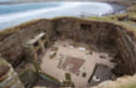
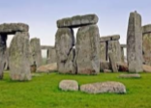

Stonehenge Skara Brae
Stonehenge is a prehistoric monument in Wiltshire, England. It consists of a ring of standing stones, with each standing stone around 13 feet high, 7 feet wide and weighing around 25 tonnes.
Skara Brae is a stone-built Neolithic settlement, located on the Bay of Skaill on the west coast of Mainland, the largest island in the Orkney archipelago of Scotland.

What? (Key Vocabulary)
Spelling | Definition/ Sentence
Palaeolithic – | The early phase of the Stone Age, about 2.5 million years ago. Stones were used as tools for bashing, cutting and scraping.
Mesolithic - | Transitional period between the Palaeolithic (Old) and Neolithic (New) eras.
Neolithic - | The youngest part of the Stone Age. The word "neolithic" comes from two words in Greek: "neo", meaning "new" and "lithic", meaning "stone". In this time, farming began and people started caring for animals, such as cows, sheep and pigs
Hunter-gatherer – | People who found food from their local environment and then moved wherever they needed to get food from.
Prehistoric – | A period of time before recorded history.
Archaeology | The study of ancient cultures through examination of their buildings, tools, and other objects
Settlement | A place where people come to live or the process of settling in such a place:
Flint | Stone that can be chipped and sharpened to create a tool
Monument | a statue, building, or structure made to remember a person or important event.
Timeline of Early Britain
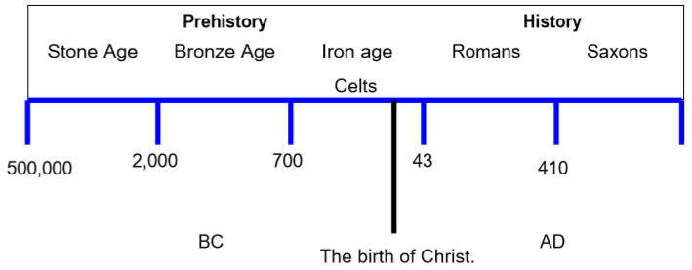

Year 3/4 Spelling Words linked to the unit of work.
circle, early, fruit, group, history, natural, special

