What? (Key Knowledge)
What is light? | Light is a type of energy that makes it possible for us to see the world around us.
What is dark? | Dark is the absence of light, so when it is dark, we cannot see anything.
What is a reflection? | Light travels in a straight line. When light hits an object, it is reflected (bounces off). If the reflected light hits our eyes, we can see the object. The surfaces that reflect light best are smooth, shiny and flat. Reflective surfaces and materials can be useful, such as wearing a hi-vis jacket when cycling in the dark. Also, cat’s eyes in the road help drivers see when driving in the dark.
How are shadows formed? | A shadow is formed when light is blocked by an opaque object. A shadow is larger when an object is closer to the light source. This is because it blocks more of the light.
How can we protect our eyes from the sun? | The light from the sun can be dangerous, as it can damage our eyes. Therefore, we must never look directly at the sun. The best way to protect our eyes is to wear sunglasses, especially ones that block 100 percent of UV rays.
Possible Experiences
Identify a variety of light sources.
Work scientifically to explore and recognise that dark is the absence of light.
Investigate which surfaces reflect light.
Create shadow puppets to explore how shadows are created.
What? (Key Vocabulary)
Spelling | Definition/ Sentence
Light | A form of energy that travels in a straight line.
Dark | The absence of light.
Energy | The ability to do work. It is a supply of power and sustains both mental and physical activity, as well as helping heat, power or provide light.
Light Source | An object that makes its own light.
Opaque | This describes objects that do not let any light pass through.
Transparent | This describes objects that let light travel through them easily, meaning you can see through the object.
Translucent | It describes objects that let some light through but scatter the light so we cannot see through them clearly.
Reflect | To bounce light from a surface.
Shadow | A dark shape or outline of something that is created when light is blocked.
Diagrams and Symbols
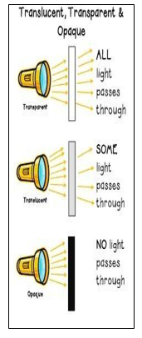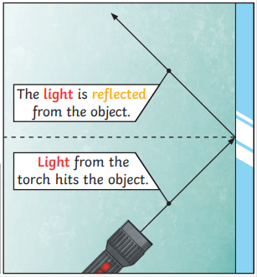
Year 3/4 Spelling Words linked to the unit of work.
Material, natural, position, straight, through

