What? (Key Knowledge)
Islam
Why do Muslims fast during Ramadam?
Islam is one of the world’s major religions. It is the world’s 2nd largest religion, with about 1.8 billion followers.
Muslims are the people who follow Islam. They believe in one God who created everything – he is called Allah (the Arabic name for ‘God’).
Muslims believe in a messenger of Allah, named Muhammad. They view him as the final prophet, following Adam, Abraham, Moses, Jesus and others.
Muhammad is believed to be the person who founded the faith of Islam, about 1,400 years ago. The holy book in Islam is called the Qur’an. A mosque is a building designed for Muslim worship.
Laws and Customs -There are many laws and customs outlined in the Qur’an, that Muslims should follow.
-They must dress modestly, e.g. many Muslims wear long clothes that cover their bodies, and women wear a hijab which covers parts of their hair/face. Food must be halal, meaning animals must be killed in a certain way.
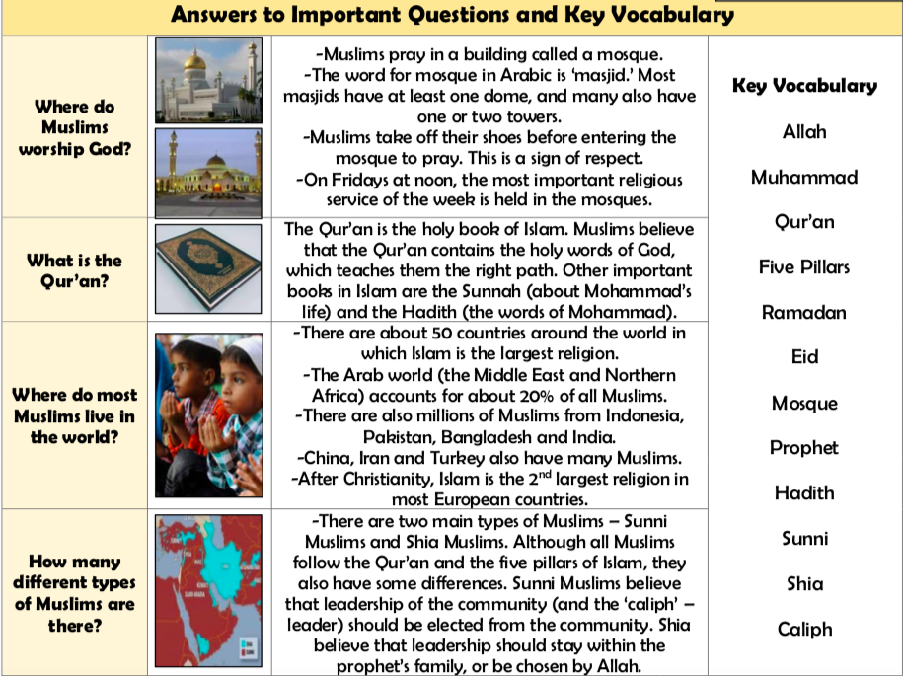

Ramadan -Ramadan is the ninth month of
the Islamic calendar. It is a month in which Muslims worldwide take part in fasting. -For the whole of the month, Muslims do not eat during daylight hours. Instead, they devote themselves to prayer and to Allah.

The Five Pillars of Islam - The Five Pillars of Islam are the behaviours and beliefs by which Muslims must live their lives. They were founded in the hadith of Gabriel.
1.Shahadah: the declaration of faith: ‘There is no God but Allah, and Mohammad is his messenger.’ 2. Salah: the five daily prayers. 3. Zakah: Giving money to help the poor. 4. Sawm: Committing to fasting during the month of Ramadan. 5. Hajj: A religious pilgrimage to Mecca that Muslims should undertake at least once in their lives.
Muhammad - Muslims believe that God sent his final message to Earth through Muhammad, 1400 years ago. He is considered so holy that Muslims say ‘peace be upon him’ whenever they say or write his name. -When he was around 40 years old, Muhammad is believed to have been approached in a cave by the angel Gabriel, who sent ‘revelations’ from Allah. He continued to receive these messages, and to teach them to others. -The messages that Muhammad received were later collected and made into the Qu’ran. Muslims believe that they should follow the example set by Muhammad throughout their own lives.

