Lunt’s Heath Primary School Knowledge Organiser. |  |  | HISTORY: EGYPTIANS |  |  | Year 4 Summer
Pyramid Construction |  | Year |  | Event | Key Vocabulary
1 | Approximately 4000 Egyptian workers built the pyramids. | 3100BC -  30BC |  | Ancient Egyptian era | linen |  | A cloth made from a plant called flax, used for making clothes or sheets.
2 | Workers cut huge blocks of stone out of the ground. | 2,640 BC |  | First pyramid is believed to be  built. | tomb |  | A large grave which is above ground with a  sculpture or decoration on it.
3 | Stones were loaded onto boats, which took them to the pyramids along the River Nile. | 2,520 BC |  | The Great Sphinx (body of a lion and head of a human) is believed to be built. | monument |  | Large structure usually made of stone, which is built to remind people of an event in history.
4 | Using a chisel and hammer, workers made the rocks smooth so they would fit together tightly. | 1,332 BC |  | The 10-year rule of Tutankhamun begins. | chisel |  | A tool which has a long metal blade with a sharp edge at the end. Used for cutting wood or stone.
5 | Workers moved the heavy blocks using wooden sledges on ramps up the side of the pyramids. | 51 BC |  | Queen Cleopatra’s reign begins. She is the last Pharaoh  of the ancient Egypt period | hieroglyphics |  | A picture used as a form of writing instead of letters.
6 | Pharaohs were usually buried under the pyramid structure although some had burial chambers built inside the pyramid. | Nov 1922 |  | Howard Carter discovers the tomb of Tutankhamun in the Valley of the Kings. | mummification |  | The process in which the flesh and skin of  a corpse (dead body) can be preserved.
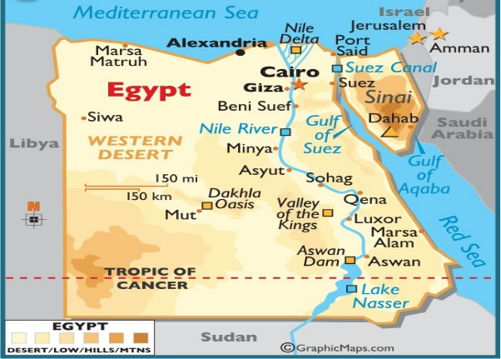  Map of Egypt.  Cairo is the capital of Egypt.  The River Nile is the longest river in the world.  People settled near the Nile as it was a useful source of water (used for drinking, washing, watering crops) |  | Key Individuals |  |  | pharaoh |  | An ancient Egyptian ruler (king or queen).
 |  | Narmer |  | – said to be the first pharaoh of all Egypt | merchants |  | A person who buys or sells goods in large quantities.
 |  | Khufu |  | – pharaoh responsible for the building of the Great Pyramid at Giza | pyramid |  | A building with triangular sides built as an Egyptian tomb (a place to bury the dead).
 |  | Hatshepsut |  | – first and longest-reigning female pharaoh | burial chamber |  | A room that is often below ground level that is used to bury the remains of the dead.
 |  | Ramses II |  | – often known as Ramses the Great, his  mummy still rests in Cairo’s Egyptian Museum. | descendants |  | A person who is related to you and who lives after you, such as your child or  grandchild.
 |  | Tutankhamun |  | – youngest pharaoh, famed for his burial tomb in the Valley of the Kings | 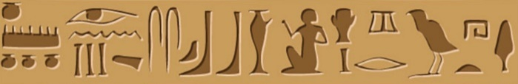  An example of hieroglyphics

