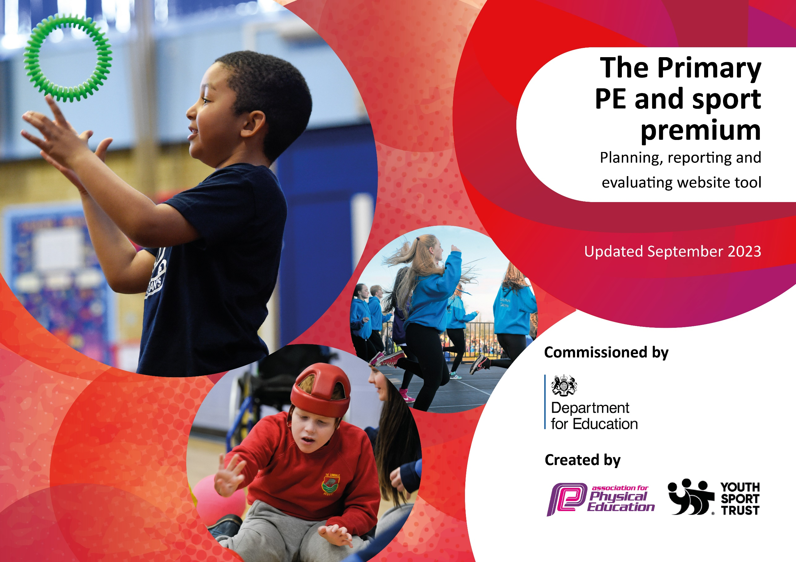

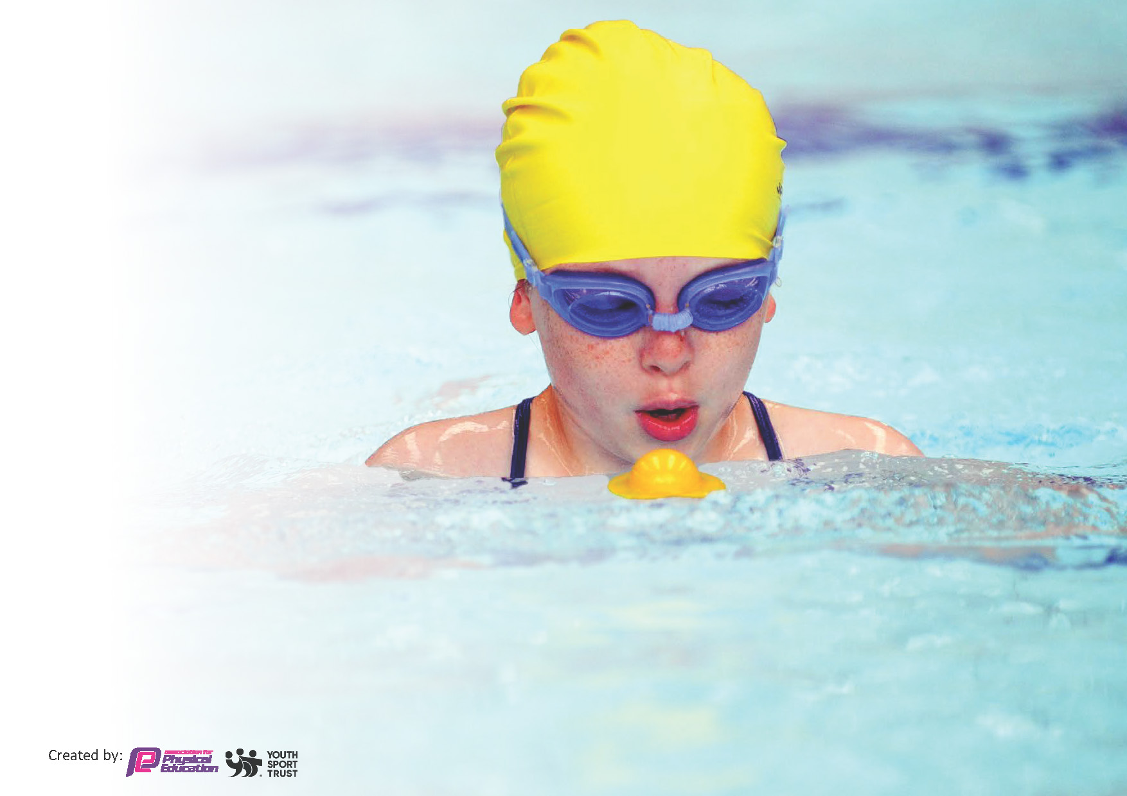
This template can be used for multiple purposes:
by:
- It enables schools to effectively plan their use of the Primary PE and sport premium
- It helps schools to meet the requirements (as set out in guidance) to publish information on their Primary PE and sport premium
- It will be an effective document to support Ofsted inspections enabling schools to evidence progress in Physical Education (PE) and evidence swimming attainment, which forms part of the PE National Curriculum. We would recommend schools consider
the Intent, Implementation and Impact of any spend, as examined within the Education Inspection Framework.

It is important that your grant is used effectively and based on school need.

Schools must use the funding to make additional and sustainable
improvements to the quality of the PE, School Sport and Physical Activity (PESSPA)
they offer. This means that you should use the Primary PE and sport premium to:

- Build capacity and capability within the school to ensure that improvements made now will benefit pupils joining the school in future years
- Develop or add to the PESSPA activities that your school already offers.

The Primary PE and sport premium should not be used to fund capital spend projects; the school’s core budget should fund these. Further detail on capital expenditure can be found in the updated Primary PE and sport premium guidance.

The Primary PE and sport premium guidance, outlines 5 key priorities that funding should be used towards. It is not

necessary that spending has to meet all the key priorities, you should select the priorities that you aim to use any funding towards.

Although completing this template is not a requirement for schools, schools are required to publish details of how they spend this funding. Schools must also outline what the impact this funding has had on pupils’ PE and sport participation and attainment and how any spending will be sustainable in the future. All funding must be spent by 31st July 2024.

The Department for Education has worked closely with the Association for Physical Education (afPE) and the Youth Sport Trust (YST) to develop this template and encourages schools to use it. This template is an effective way of meeting the reporting requirements of the Primary PE and sport premium.
Review of last year’s spend and key achievements (2022/2023)

We recommend you start by reflecting on the impact of current provision and reviewing your previous spend.

Activity/Action | Impact | Comments
OPAL play based learning scheme. This improved the lunchtime and playtime provision in school for all children  CPD specialist in Dance  Competition entry and various levels | Children happily engaged in physical activity each day, including scooters, Go-Karts, climbing bars and a dance stage  Dance has a higher profile across school, with completions and festivals now being entered  Children of all abilities have now accessed completions where this had not always been possible. | Long-term, sustainable play activities  Summer dance camps in school have fully engaged the children further  Children now discussing which competitions they wish to attend next.

Key priorities and Planning
This planning template will allow schools to accurately plan their spending.

Action – what are you planning to do | Who does this action impact? | Key indicator to meet | Impacts and how sustainability will be achieved? | Cost linked to the action
Sports Captains’ programme is introduced to promote active play.  Ensure that we have the equipment to enable us to perform safe lessons  Utilise Lunchtime Play sessions to encourage creativity and develop self-regulated play  Challenge Children to develop own fitness levels through new MOKI Watched | Staff released to observe and plan the programme working across the Network schools. Staff are deployed to introduced to plan, deliver and teach sports’ leader activities.  New equipment ordered to make sure that lessons adhere to government guidelines  New curriculum play lead through OPAL for the children  Mile and Daily Mile monitored by the children and staff | Key indicator 1: The engagement of all pupils in regular physical activity – Chief Medical Officers guidelines recommend that primary school pupils undertake at least 30 minutes of physical activity a day in school | Pupils will confidently engage in activities at playtimes using equipment effectively. New play equipment to be purchased to enhance Play Leaders’ role  Pupil and staff voice will indicate that playtimes are active and enjoyable with fewer incidents and accidents.  Lessons are able to be taught keeping children and staff without losing the impact of lessons on learning.  Children develop better play practices and how they can increase resilience  Purchase further MOKI Watches | £320  £1270.92  £2210  £760 per set x 2

Maintaining the high profile for PEPSA by hiring specialist P.E. practitioners which encourages pupils and teachers to engage in healthy lifestyles.  Raising teacher competencies in P.E. via high quality professional development leading to high quality lesson delivery.  Increase staff confidence teaching PE  Continue to invest in PE passport to support teaching and assessment of PE  Investment in high quality after school clubs run by specialists such as external clubs and visits  Wider opportunities for pupils – visit high-profile sporting events  External opportunities for children to experience a sport which we cannot offer in school  To maintain the high volume of pupils attending enrichment activity and inter-school competition – e.g. Widnes inter-school competitions and School Games. Increased opportunity will improve pupils’ motivation and social interaction thus having an impact on children’s academic achievement. | Work with ECB to provide sessions of high quality, with clear exit strategies. Coach delivering motor skills courses throughout the year.  Work with Active Halton Sports Development to provide a range of minority sports that children would not otherwise have exposure to.  Network 6 Subject Leader programme – collaboration and events across the year  Nutritional specialist working with UKS2 to help develop self-esteem and fitness links in Summer 2023  Dance Specialist working with all year groups and staff to uplevel their CPD in Dance  Bespoke CPD packages for staff to develop increased expertise in the area of P.E.  Specialist PE teacher (Danny Lynch) one day a week to work with staff ‘team teaching’ PE focusing on building their confidence  Teachers to understand and use the scheme to increase confidence teaching and assessing PE  Gather pupil voice on their opinions of after school clubs  Broader range of after school clubs able to be offered  Children to get ‘ wow ‘ experiences that they wouldn’t usually have  Increasing opportunity via attendance at inter-school competition.  Bus hire for attending.  Supply cover to free travelling staff. Membership fees, affiliation and entry fees to a range of competitions and events. | Key indicator 2: The profile of PESSPA being raised across the school as a tool for whole school improvement  Key indicator 3: Increased confidence, knowledge and skills of all staff in teaching PE and sport  Key indicator 4: Broader experience of a range of sports and activities offered to all pupils  Key indicator 5: Increased participation in competitive sport | Raised quality of teaching, learning and assessment resulting in high levels of pupil engagement. Develop further range of sports across  Opportunities to develop a wider set of physical literacy skills has been obtained. Further links with other schools and colleges to help ensure exit strategies  increased levels of pupil self-esteem and confidence. Extend the competitions to embrace further  Increased levels of pupil self-esteem and confidence. New curriculum teams to plan out further CPD sessions as part of their inset.  Children experience a broad range of sporting opportunity including minority sports. Competitions and events for the children to attend is extended  CPD that raises the staff confidence levels. Develop further CPD programme for all staff, including MDAs and TAs  Deep Dive evidence improvements to the quality of education. New curriculum teams to plan out further CPD sessions as part of their inset.  Staff are more confident and knowledgeable in the delivery of PE curriculum – evidence from staff voice. Assessment of PE will become a strength in school  Higher uptake on after school clubs. Ensure that all enrichment links to the requirements of the children.  Children to gather interest and a love of sport and staying active. Further visits to high quality sporting events.  Large proportion of children having opportunities to participate in inter-school sporting activity. | . £3500  £1590  £1000  £300  £1000  £1000  £2,790  £400  Time  £1500  £1000  £1200

Key achievements 2023-2024
This template will be completed at the end of the academic year and will showcase the key achievements schools have made with their Primary PE and sport premium spending.

Activity/Action | Impact | Comments

Swimming Data
Meeting National Curriculum requirements for swimming and water safety.
Priority should always be given to ensuring that pupils can perform safe self-rescue even if they do not fully meet the first two requirements of the National Curriculum programme of study

Question | Stats: | Further context  Relative to local challenges
What percentage of your current Year 6 cohort can swim competently, confidently and proficiently over a distance of at least 25 metres? | 80% | Use this text box to give further context behind the percentage.  e.g., 30% - we are struggling to get pool space due to our local pool closing so we have had to use a much smaller local school pool. We have had to limit the number of pupils attending swimming lessons during one term which means some pupils have attended fewer swimming lessons than others.
What percentage of your current Year 6 cohort can use a range of strokes effectively [for example, front crawl, backstroke, and breaststroke]? | 80% | Use this text box to give further context behind the percentage.  e.g., Even though your pupils may swim in another year please report on their attainment on leaving primary school at the end of the summer term 2024

What percentage of your current Year 6 cohort are able to perform safe self-rescue in different water-based situations? | 80% | 6 week block sessions for children with regular water safety sessions in year 3 and 4, with catch up through years 5 and 6
If your schools swimming data is below national expectation, you can choose to use the Primary PE and sport premium to provide additional top-up sessions for those pupils that did not meet National Curriculum  requirements after the completion of core lessons. Have you done this? | Yes/No | 6 week block sessions for children with regular water safety sessions in year 3 and 4, with catch up through years 5 and 6
Have you provided CPD to improve the knowledge and confidence of staff to be able to teach swimming and water safety? | Yes/No | 6 week block sessions for children with regular water safety sessions in year 3 and 4, with catch up through years 5 and 6

Signed off by:

Head Teacher: | Dave Paton
Subject Leader or the individual responsible for the Primary PE and sport premium: | Abigail McLindon
Governor: | Mike Holden
Date: | 1st September 2023

